Question 1: We are asked to find the pattern of an antenna whose current distribution is given as:

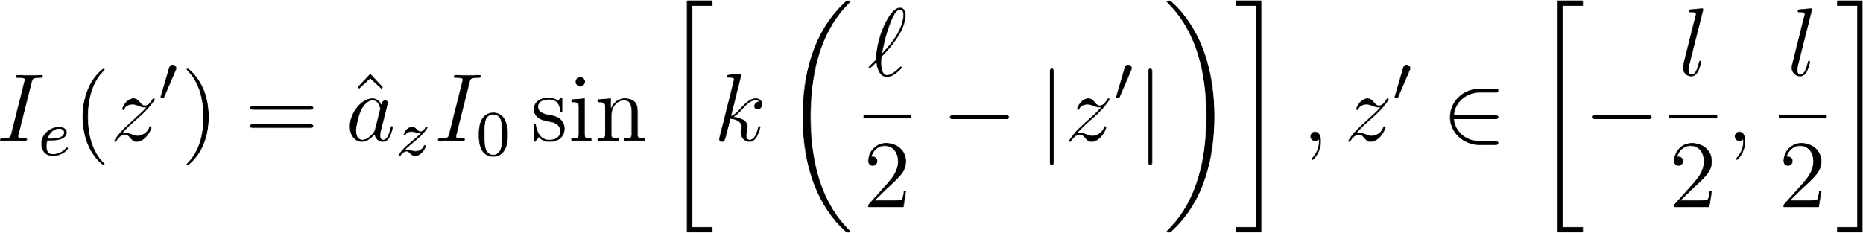

We write this as the sum of an infinite number of Hertzian dipoles. The fields due to a z-directed Hertzian dipole are given as:

We can calculate the E-fields as:

Notice that the integral is in the same form as PS1, Q2-a. We plug in the solution and obtain the expression for the E-field as:

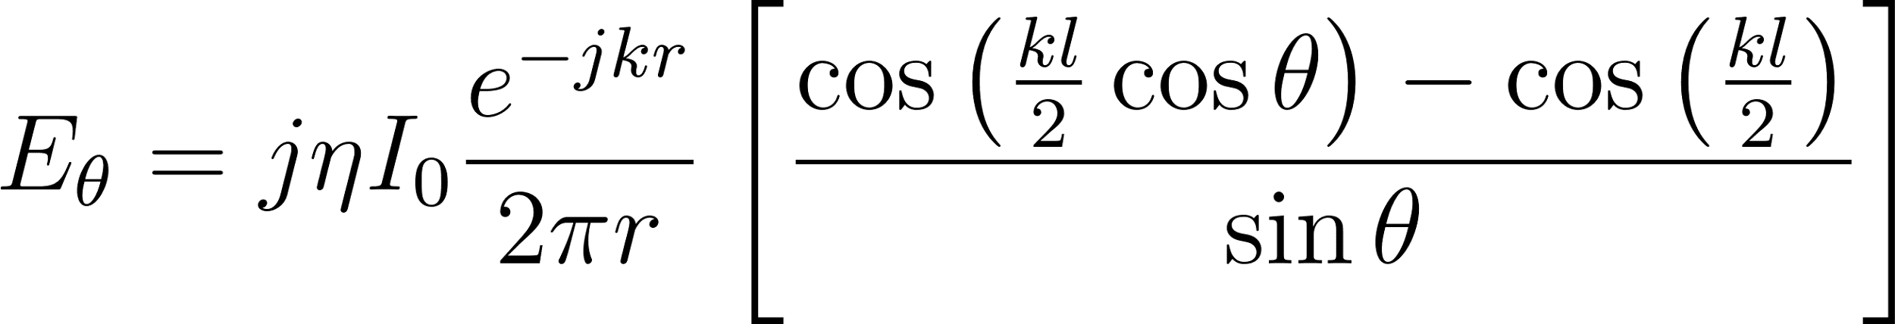

By using the plane wave approximation, we can obtain the H-field expression as:

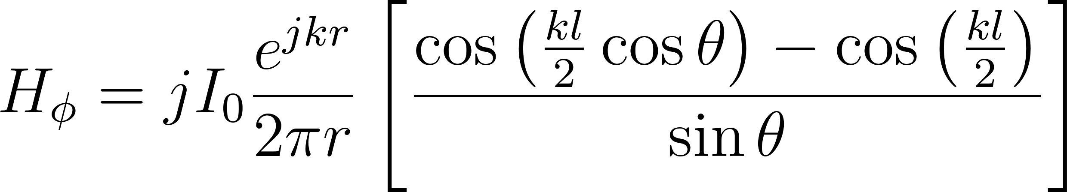

From these, we can obtain the field amplitude plots for the values $l=0.25λ, 0.5λ, λ$ of antenna length as:
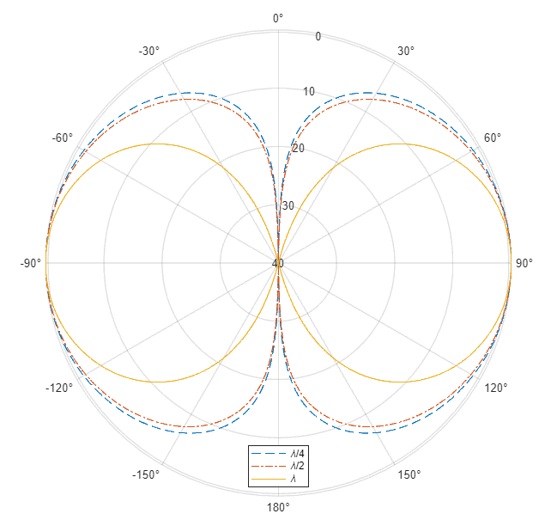
Figure 1: Field Amplitude Patterns for Linear Antennas with Various Lengths

Question 2: Similarly, by plugging in the required value to the same expression we found in question 1, we can obtain the following plot:
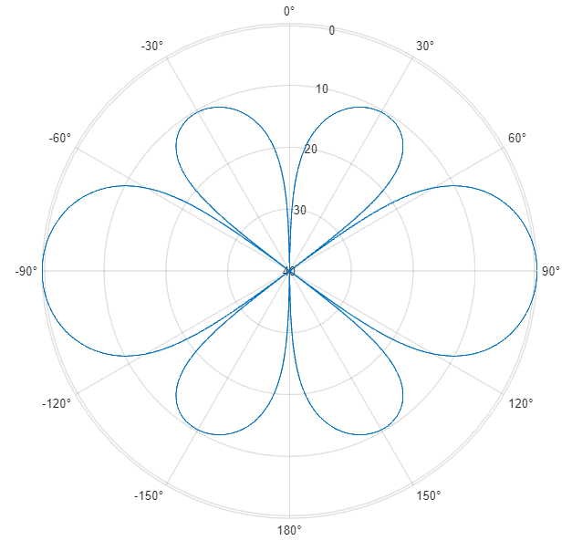
Figure 2: Field Amplitude Patterns for Linear Antenna with $l=1.25λ$
Question 3: In this question, we are given a Hertzian dipole and a perfect electric conductor (PEC) plane. We can consider this geometry as two Hertzian dipoles using image theory. By modifying the expression for the fields of a Hertzian dipole, we can obtain:

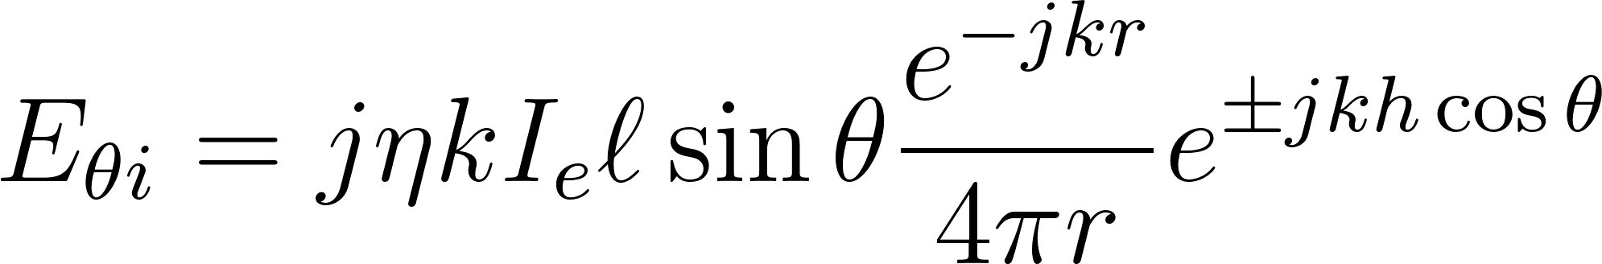

If we add these two components, we obtain:

It should be noted that this result holds for $z>0$or equivalently $θ<\frac{π}{2}$ since, within the PEC plane, there can be no electric fields. We can go ahead and plug in $h=0.25λ, 0.5λ, λ$and plot our results.

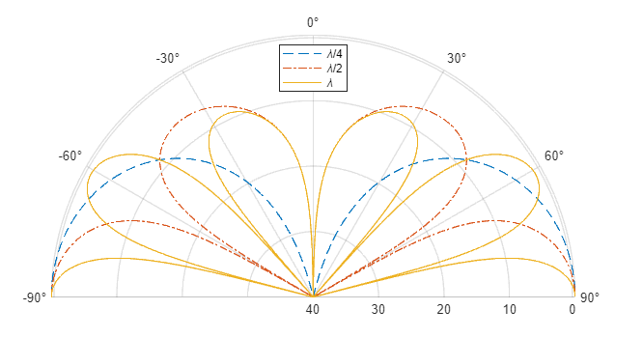
Figure 3: Field Patterns for Z-Directed Dipole above PEC with Various h Values

Question 4: Similarly, we can plug in $h=5λ$ in the expression that we found, and we can plot the result as seen in Figure 4. It should again be noted that this result holds for $z>0$or $θ<\frac{π}{2}$.

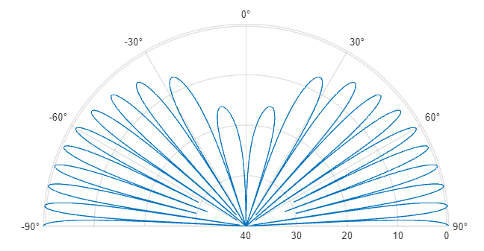
Figure 4: Field Patterns for Z-Directed Dipole above PEC with $h=5λ$

Question 5: We can write the expression for a y-directed Hertzian dipole as obtained in PS5, Q2-d. We can also model this geometry as two y-directed Hertzian dipoles carrying current in opposite directions, using image theory.

We can add the fields due to both dipoles and find the fields as:

For $ϕ=\frac{π}{2}$, these expressions simplify further:

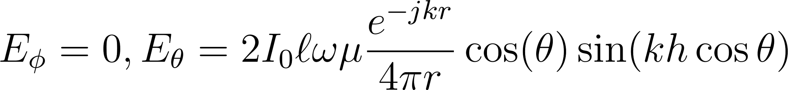

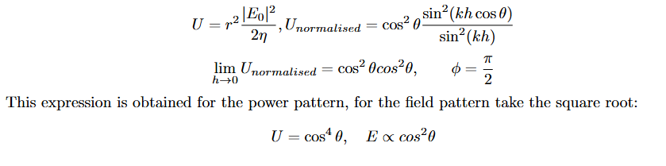
Again, due to the PEC plane at $z=0$, these expressions only hold for $z>0$ or $θ<\frac{π}{2}$. However, we have an entirely different case for $h→0$. We need to calculate the limit as:

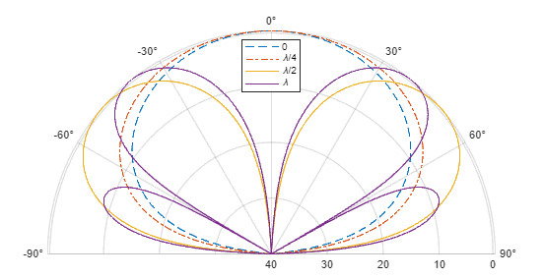
Figure 5: Field Patterns for Y-Directed Dipole above PEC with Various h Values

Question 6: Similarly we can obtain the solution for $h=5λ$ by plugging it in. Again, due to PEC plane at $z=0$, these expressions only hold for $z>0$ or $θ<\frac{π}{2}$.
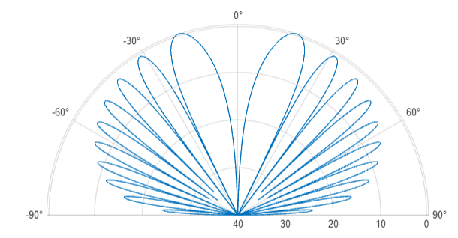
Figure 6: Field Patterns for Y-Directed Dipole above PEC with $h=5λ$

Question 7: This question features a loop antenna. We can find the fields of a loop antenna as follows:

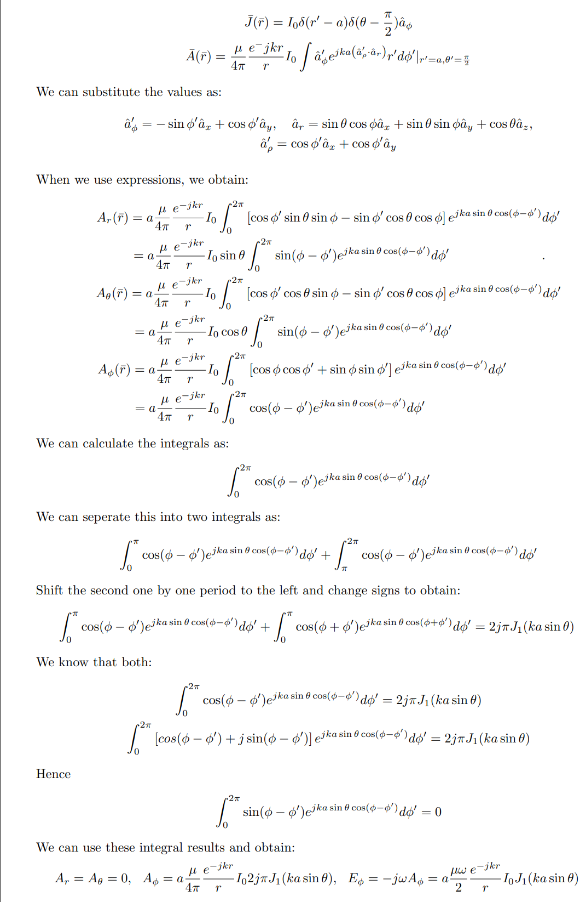
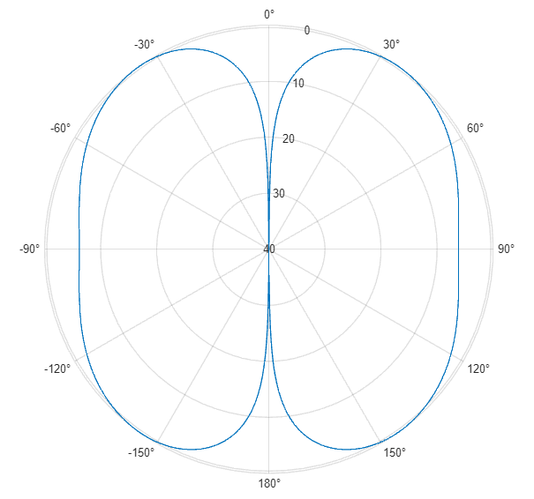
Figure 7: Field Pattern of a loop antenna with radius $a=λ/2.$

Appendix A: Spherical Pattern Plot
The figure in Balanis featured a 3D pattern for Question 2. Here is a way to obtain the same plot:

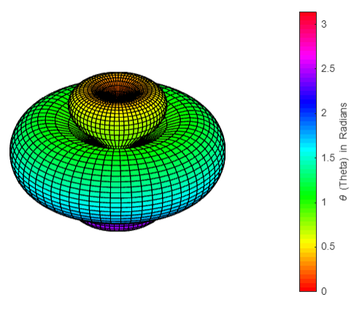
Figure B1: Spherical Pattern of Question 2

Matlab Code for the Spherical Plot:
theta = linspace(0, pi, 64);
phi = linspace(0, 2*pi, 64);

[Phi, Theta] = meshgrid(phi, theta);

E2_1 = (cos(2*pi*1.25*0.5*cos(abs(Theta)))-cos(2*pi*1.25*0.5))./sin(abs(Theta));
E2_1 = abs(E2_1);
E2_1 = E2_1/max(E2_1);
E2_1 = 20*log10(E2_1+10^-12);
E2_1 = (E2_1 + 40).*((E2_1+40)>=0)/40;

r = E2_1;

X = r .* sin(Theta) .* cos(Phi);
Y = r .* sin(Theta) .* sin(Phi);
Z = r .* cos(Theta);

surf(X, Y, Z, Theta);
colormap(hsv(64));
colorbar
cb = colorbar;
cb.Label.String = '\theta (Theta) in Radians';
axis equal
box off
grid off
axis off

Appendix B: MATLAB Code
Q1
theta_deg_180 = linspace(-180,180,2000);
theta_180 = deg2rad(theta_deg_180);
clf;

%Generate e-fields for Q1
lengths = [1/4, 1/2, 1];
E1_1 = (cos(2*pi*lengths(1)*0.5*cos(theta_180))-cos(2*pi*lengths(1)*0.5))./sin(theta_180);
E1_2 = (cos(2*pi*lengths(2)*0.5*cos(theta_180))-cos(2*pi*lengths(2)*0.5))./sin(theta_180);
E1_3 = (cos(2*pi*lengths(3)*0.5*cos(theta_180))-cos(2*pi*lengths(3)*0.5))./sin(theta_180);

%plot the values
eps = 10^-12;
field_pattern_plot(theta_180,E1_1,'--')
hold on
field_pattern_plot(theta_180,E1_2,'-.')
field_pattern_plot(theta_180,E1_3,'-')
legend({'\lambda/4','\lambda/2','\lambda'},'Location','south')
hold off
Q2
E2_1 = (cos(2*pi*1.25*0.5*cos(theta_180))-cos(2*pi*1.25*0.5))./sin(theta_180);
field_pattern_plot(theta_180,E2_1,'-')
Q3
h = [0.25 0.5 1];
theta_deg_90 = linspace(-90,90,1000);
theta_90 = deg2rad(theta_deg_90);
E3_1 = sin(theta_90).*cos(2*pi*h(1)*cos(theta_90));
E3_2 = sin(theta_90).*cos(2*pi*h(2)*cos(theta_90));
E3_3 = sin(theta_90).*cos(2*pi*h(3)*cos(theta_90));

field_pattern_plot(theta_90,E3_1,'--')
hold on
field_pattern_plot(theta_90,E3_2,'-.')
field_pattern_plot(theta_90,E3_3,'-')
legend({'\lambda/4','\lambda/2','\lambda'},'Location','south')
hold off
Q4
E4_1 = sin(theta_90).*cos(2*pi*5*cos(theta_90));
field_pattern_plot(theta_90,E4_1,'-')
Q5
h = [0 0.25 0.5 1];

E5_1 = cos(theta_90).^2; %pattern of hertzian dipole by itself
E5_2 = cos(theta_90).*sin(2*pi*h(2)*cos(theta_90));
E5_3 = cos(theta_90).*sin(2*pi*h(3)*cos(theta_90));
E5_4 = cos(theta_90).*sin(2*pi*h(4)*cos(theta_90));

field_pattern_plot(theta_90,E5_1,'--')
hold on
field_pattern_plot(theta_90,E5_2,'-.')
field_pattern_plot(theta_90,E5_3,'-')
field_pattern_plot(theta_90,E5_4,'-')
legend({'0','\lambda/4','\lambda/2','\lambda'},'Location','north')
hold off
Q6
E6_1 = cos(theta_90).*sin(2*pi*5*cos(theta_90));
field_pattern_plot(theta_90,E6_1,'-')
Q7
E7_1 = besselj(1,2*pi*0.5*sin(theta_180));
field_pattern_plot(theta_180,E7_1,'-')
Functions
function y = normalise(x)
y = x/max(x);
end

function y = trunc(x) % rounds everything below -40dB up to -40dB. Maps -40,0 to 0,1
y = ((x+40).*(x+40>0)./40);
end

function field_pattern_plot(theta,E1,style)
eps = 10^-12;
polarplot(theta,trunc(20*log10(eps+normalise(abs(E1)))),style)
thetalim([min(theta)*180/pi max(theta)*180/pi]); % only 0–180°
rlim([0 1])
rticks([0 0.25 0.5 0.75 0.99])
rticklabels([40 30 20 10 0]); % dB rings

thetaticks(min(theta)*180/pi:30:max(theta)*180/pi);
ax = gca;
ax.ThetaZeroLocation = 'top'; % 0° at the top
ax.ThetaDir = 'clockwise'; % match antenna books
set(gcf,'position',[1 , 1 , 700 , 700])

end

